# Intro to Power Query

## What is a Power Query?

Power Query is a game-changing data connectivity and transformation technology in Microsoft Excel, Power BI, and other Microsoft products. It empowers any person to connect to a rich set of external data sources and even local data in a spreadsheet and collect, combine, and transform the data by using a simple user interface.

* In short we all have spreadsheets and word documents , psd files, database that store information that can look like this:

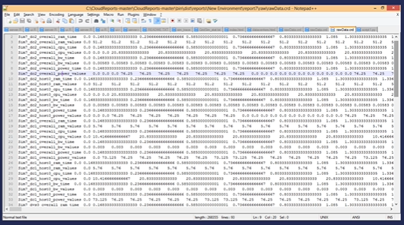

* What query does is it helps turn the data into

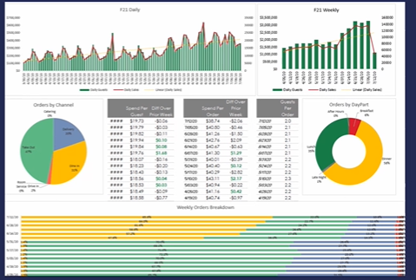

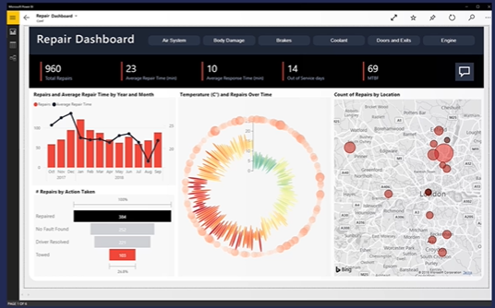

* As we go back and look at the data in just ones and zeros and descriptions that when we apply logic and visualization it will answer business questions that we have in a much easier way.

## Business users spend up to 80% of their time on data preparation

* Finding & connecting data
* Data connectivity is fragmented
* Data needs to be reshaped
* Shaping needs to be repeated
* The 3 Vs
  + Variety, volume and velocity

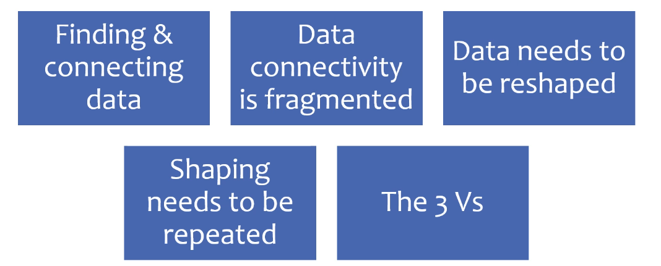

## Where to find Power Query

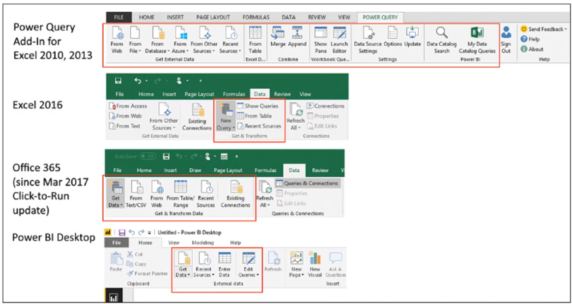

* When opening the Power Query

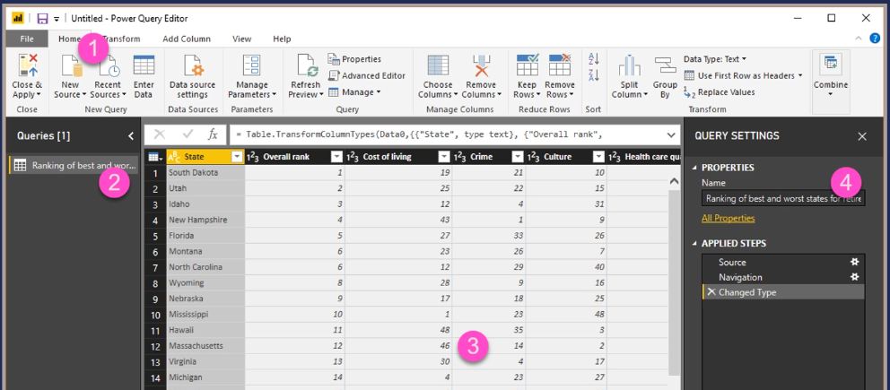

1. Ribbon
   1. Will change based on the tab that you chose
2. Queries
3. Preview Pane
   1. Preview your data, explore and prepare it
4. Query Settings
   1. Where you can rename query, provide description and transformation steps.

## The Power Query Formula Language (M)

In any data transformation scenario, there are some transformations that can’t be done in the best way using the graphical editor. Some of these transformations might require special configurations and settings that the graphical interface doesn’t currently support. The power Query engine uses a scripting language behind the scenes for all Power Query transformations called the Power Query Formula Language, also known as M.

## Getting Data

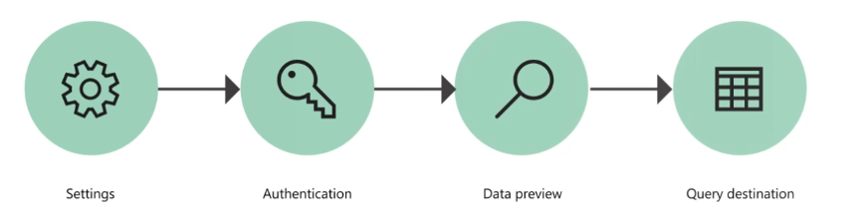

* When you are using Power Query you are using 4 distinct steps
  + **Settings**
    - What is the data I need, where is it located, whats the format of of that data, and your going to identify where you are going to get it from and what it looks like
  + **Authentication**
    - Making sure that you have the right level of access to the data not only you who are building out the data model but also subsequent users of the data model that they will have the right level of authentication
  + **Data preview**
    - Making sure that you are viewing the right type of data before you ultimately decide where the query destination is going to be. That can be loaded directly into the data model, power query reports, or it can just be maintained as a connection to your original data source
  + **Query destination**

## Authentication

* The currently available methods of authentication for Power Query are:
* **Anonymous**
  + Commonly used when connecting to data source that doesn’t require user authentication, such as web page, a file available over public HTTP, and so on
* **Basic** 
  + Accepts a username and password to be sent in base64 encoding
* **API Key**
  + accepts a single API key for authentication
* **Organizational account / Microsoft Account** 
  + also known as OAuth 2.0
* **Windows** 
  + can be implicit or explicit
* **Database** 
  + only available in some database connectors

## Privacy Levels

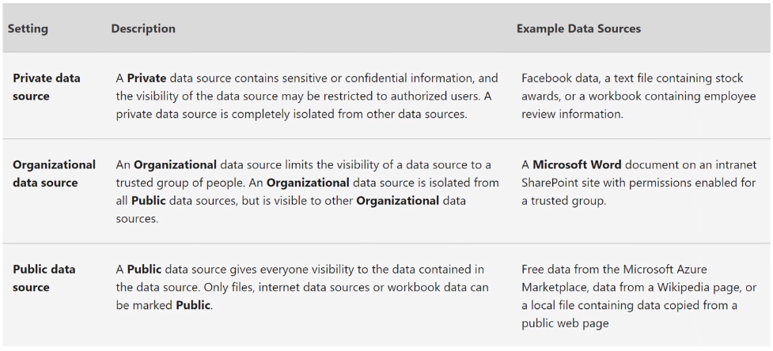

## Navigator Window

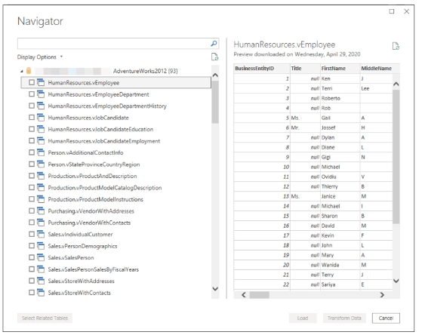

* You get preview of the data
* Once you made the connection you will see that data. You can select he individual tables/files/worksheets then we can transform and load it into our data

## Ribbon

### Transform Tab

* The **transform** tab provides access to common data transformation tasks, such as adding or removing columns, changing data types, splitting columns, and other data-driven tasks. The following image shows the **Transform** Tab.

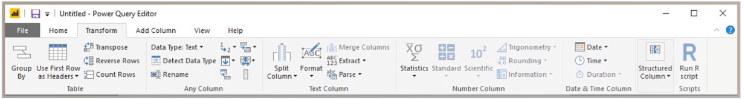

### Add Column

* The add column tab provides additional tasks associated with adding a column, formatting column data, and adding custom columns. The following image shows the Add Column tab.

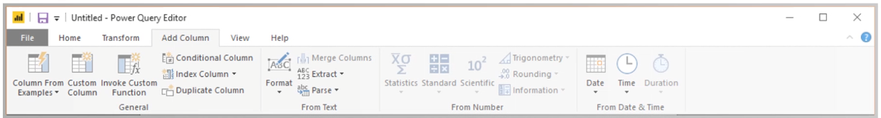

### View Tab

* The view tab on the ribbon is used to toggle whether certain panes or windows are displayed. It’s also used to display the Advanced Editor. The following image shows the View tab.

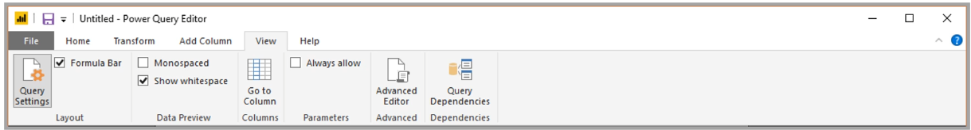

## The Query Settings Pane

* It’s important to know that the underlying data is not changed; rather, Power Query Editor adjusts and shapes its view of the data, and any interaction with the underlying data occurs based on Power Query Editor’s shaped and modified view of that data

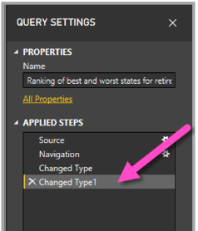

## Combining Queries

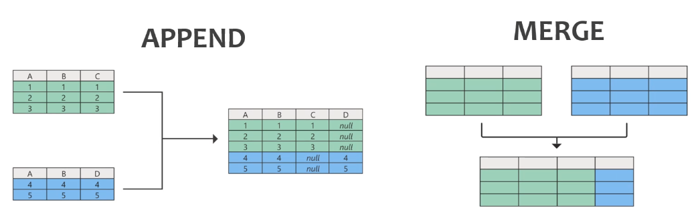

Append

* When you have two sets of data tha t fundamentally the same with the same columns but creating a longer list. Ex invoice data by years 2019 and 2020 info

Merge

* Combine information that is fundamentally different. Ex customer in two different places. One system you will have the specific customer ID that you want to combine with information that resides in a different system. As long as you have a consistent identifier for that customer you can merge that information together to get a broader view.
* When you are doing a merge query it required that you say what kind of join you are doing with your tables.

## Join Types

### Left Outer Join

* A left outer join keeps all the rows from the left table and brings any matching rows from the right table

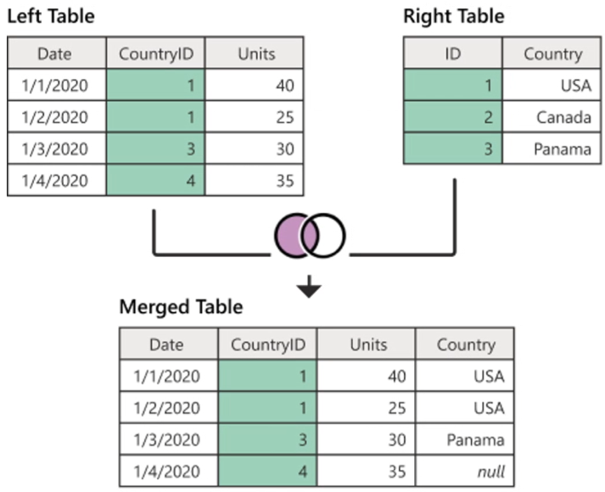

### Right Outer Join

* A right outer join keeps cal the rows from the right table and brings any matching rows from the left table

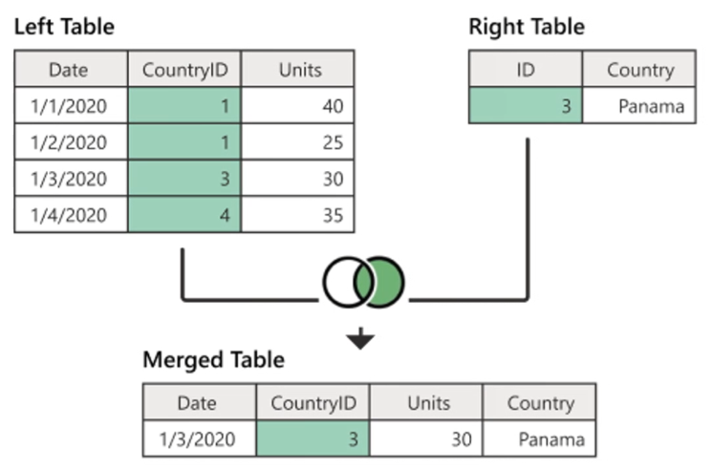

### Full Outer Join

* A full outer join brings in all the rows from both the left and right table

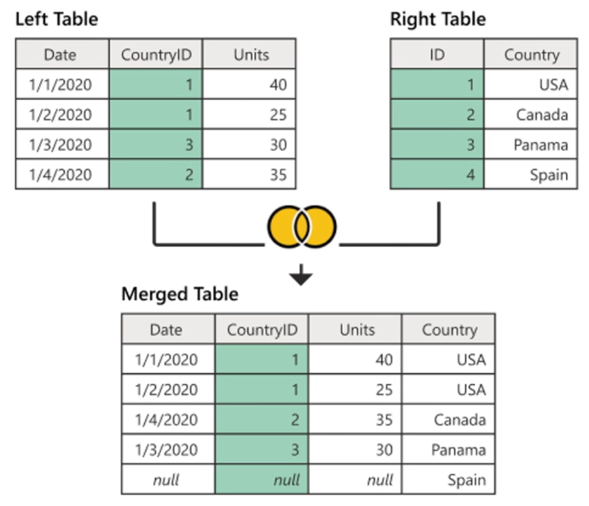

### Inner Join

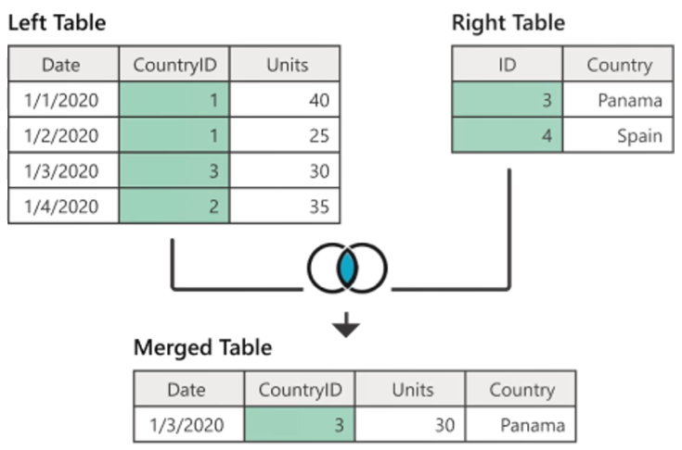

* An inner join brings only matching rows from both the left and right table

### Right Anti Join

* A right anti join brings only rows from the right table that don’t have any matching rows from the left table

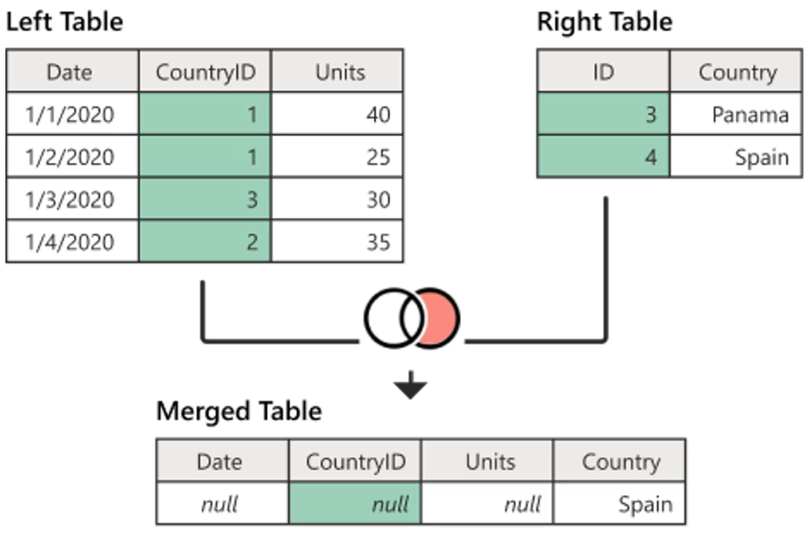’

## Best Practices

